Epsom & Ewell F.C.
3
v
Redhill
Saturday, 2nd September 2017 – 3.00 p.m.
Good afternoon and welcome to High Road for today’s League match; our first at home on a Saturday this season! We welcome the players, supporters and officials of Redhill and wish them a safe journey home.

We defeated our opponents on both occasions when we last met two seasons ago and have an excellent recent record against them, although that really depends on your definition of recent! We used to meet each other on several occasions in the past watched by thousands before the war, including the 1929 Surrey Senior Cup Final when the Lobsters held the trophy for the first time, while we would have to wait for another 52 years to raise it! Our record wasn’t so good back then, but we have won our last six meetings dating back to 1976 without conceding a goal.

It could be argued that this particular run is in real danger tonight as we have started the season in a poor manner, conceding 22 goals in our opening five matches, which is a club record. Still, when you have such a turnaround in players it is bound to take time for them to get used to each other. It should be remembered that we have only conceded two goals in our last game and a half!

For those who will there, they will not need reminding of our last home match against Chertsey Town, who thumped us 7-2, leading 6-1 after just 31 minutes which regrettably set another new record. We then suffered a 5-0 thrashing at Sutton Common Rovers on the Monday night with many of our former players playing and scoring four of the goals between them.

We then visited Colliers Wood United on the Friday evening where we were in big trouble by half time, trailing 4-0 against a very dangerous attacking unit. We recovered well to “win” the second half by two goals to one, even though the final score of 5-2 was still humbling. Tayo Ajayi and Kyle Hough scored our goals but Ajayi was injured soon after and missed the Monday morning trip to Banstead.

However, our front pair did well enough in his absence and Kyle scored once again to put us in front after 50 minutes but we weren’t able to hold on and they equalised in the 86th minute. This was our first point of the season but we remain at the foot of the table for now with much work still to do, starting today.

Our next home game is in seven days when we host Spelthorne Sports and then Horley Town visit us on the following Tuesday. These home matches are very important for our boys, so please come along again and bring your friends too!

Enjoy the game.

Rich

Don’t forget, you can follow us on Facebook: www.facebook.com/epsomandewellfc
Twitter: @EEFCOfficial Instagram at: www.instagram.com/epsomandewellfc
and Youtube at: www.youtube.com/channel/UCtLrpS0x5OaYUACRT34_zng

Cover photos by Gemma Jarman

- Daniel Rose and Jason Nwachukwu celebrate Kyle Hough’s goal at Banstead

- Joe Loftus-Cheek opens the scoring against CB Hounslow in our first League match

Cherry Red Records Combined Counties League
Premier Division Table 2017/18
inc Tuesday 29th August | P | W | D | L | F | A | Pts | GD | H | A
Westfield | 5 | 5 | 0 | 0 | 23 | 1 | 15 | +22 | 14/4 | 9/12
Bedfont Sports | 5 | 4 | 1 | 0 | 14 | 6 | 13 | +8 | 24/3 | 4/11
Hanworth Villa | 5 | 2 | 3 | 0 | 10 | 6 | 9 | +4 | 23/9 | 10/2
Guildford City | 3 | 3 | 0 | 0 | 5 | 1 | 9 | +4 | 2/12 | 7/4
Spelthorne Sports | 5 | 3 | 0 | 2 | 11 | 11 | 9 | 0 | 9/9 | 27/1
Colliers Wood United | 4 | 2 | 2 | 0 | 12 | 5 | 8 | +7 | 30/3 | 2-5
Sutton Common Rovers | 5 | 2 | 1 | 2 | 9 | 5 | 7 | +4 | 3/2 | 0-5
Walton & Hersham | 4 | 2 | 1 | 1 | 6 | 5 | 7 | +1 | 30/12 | 21/4
Camberley Town | 4 | 2 | 1 | 1 | 7 | 7 | 7 | +0 | 10/3 | 14/10
Knaphill | 5 | 2 | 1 | 2 | 9 | 12 | 7 | -3 | 24/2 | 7/10
Abbey Rangers | 5 | 2 | 1 | 2 | 7 | 10 | 7 | -3 | 16/12 | 17/2
Balham | 5 | 2 | 1 | 2 | 6 | 9 | 7 | -3 | 20/1 | 25/11
Horley Town | 5 | 2 | 0 | 3 | 7 | 9 | 6 | -2 | 12/9 | 23/12
CB Hounslow United | 5 | 1 | 2 | 2 | 10 | 11 | 5 | -1 | 13/2 | 2-4
Godalming Town | 5 | 1 | 2 | 2 | 5 | 9 | 5 | -4 | 11/11 | 13/1
AFC Hayes | 5 | 1 | 1 | 3 | 6 | 8 | 4 | -2 | 28/4 | 18/11
Redhill | 5 | 1 | 1 | 3 | 7 | 11 | 4 | -4 | 2/9 | 6/1
Farnham Town | 5 | 1 | 1 | 3 | 7 | 12 | 4 | -5 | 14/11 | 16/9
Chertsey Town | 5 | 1 | 0 | 4 | 9 | 11 | 3 | -2 | 2-7 | 31/10
North Greenford United | 4 | 0 | 3 | 1 | 4 | 7 | 3 | -3 | 28/10 | 17/3
Banstead Athletic | 3 | 0 | 1 | 2 | 3 | 6 | 1 | -3 | 2/4 | 1-1
Epsom and Ewell | 5 | 0 | 1 | 4 | 7 | 22 | 1 | -15 | X | X
1

Lucky Day? – 2nd September
Played 14 - Won 5 Drawn 2 Lost 7 - For 18 Against 23 - PPG 1.21 - Below Average
Our Club record against today’s opponent
Played 33 - Won 14 Drawn 2 Lost 17 - For 63 Against 69 - PPG 1.33 - Average
Our Largest wins and losses against today’s opponent
10th March 1928 Won 7-2 - East Surrey Hospital Cup (H)
12th December 1925 - L 2-8 - East Surrey Hospital Cup (H)
Their Last Visit
2nd February 2016 - Won 3-0 - Combined Counties League

First Eleven Appearances 2017/18 - (max 6)
Name | Debut | 2016/17 |  |  |  | Career Totals
 |  | App | Sub | Total | Goals | App | Sub | Total | Goals
AJAYI Tayo | 06/08/2017 | 3 | 1 | 4 | 1 | 3 | 1 | 4 | 1
BROOKS Jordan | 06/08/2017 | 3 | 0 | 3 | 0 | 3 | 0 | 3 | 0
CASTELL Cristian | 06/08/2017 | 2 | 1 | 3 | 0 | 2 | 1 | 3 | 0
DEWAR Ali | 29/10/2011 | 1 | 1 | 2 | 0 | 56 | 41 | 97 | 10
DYSON Ben | 12/08/2017 | 5 | 0 | 5 | 0 | 5 | 0 | 5 | 0
GRIFFIN Reisse | 08/08/2015 | 5 | 0 | 5 | 0 | 78 | 13 | 91 | 6
HARLAND-GODDARD Tom | 06/08/2017 | 1 | 1 | 2 | 0 | 1 | 1 | 2 | 0
HARRIS Colin | 04/08/2012 | 5 | 0 | 5 | 0 | 30 | 0 | 30 | 0
HATFIELD Jamie | 11/11/2006 | 1 | 0 | 1 | 0 | 250 | 13 | 263 | 6
HAYWARD Ben | 07/03/2007 | 2 | 1 | 3 | 0 | 245 | 29 | 274 | 18
HENDRY Rob | 08/08/2015 | 3 | 0 | 3 | 2 | 71 | 22 | 93 | 25
HOUGH Kyle | 14/08/2007 | 4 | 2 | 6 | 3 | 337 | 21 | 358 | 204
JARMAN Mark | 08/08/2009 | 0 | 0 | 0 | 0 | 136 | 51 | 187 | 76
LAW Franky | 06/08/2017 | 3 | 0 | 3 | 0 | 3 | 0 | 3 | 0
LOFTUS-CHEEK Joe | 06/08/2017 | 6 | 0 | 6 | 2 | 6 | 0 | 6 | 2
MARVELL Dale | 15/01/2000 | 4 | 1 | 5 | 0 | 273 | 50 | 323 | 86
MCKAY Alex | 20/12/2008 | 0 | 0 | 0 | 0 | 131 | 37 | 168 | 12
MURPHY Scott | 20/01/2007 | 1 | 0 | 1 | 0 | 13 | 2 | 15 | 1
MYERS Antony | 23/12/2006 | 1 | 0 | 1 | 0 | 76 | 33 | 109 | 9
NWACHUKWU Jason | 01/10/2016 | 3 | 2 | 5 | 0 | 20 | 18 | 38 | 1
O'BRIEN Louis |  | 1 | 1 | 2 | 0 | 1 | 1 | 2 | 0
ROBERTS Liam | 12/08/2017 | 2 | 1 | 3 | 0 | 2 | 1 | 3 | 0
ROBINSON Sam | 22/10/2011 | 4 | 0 | 4 | 0 | 65 | 6 | 71 | 14
ROSE Daniel | 25/10/2016 | 3 | 1 | 4 | 0 | 5 | 6 | 11 | 0
SMITH Andy | 25/08/2017 | 1 | 0 | 1 | 0 | 1 | 0 | 1 | 0
THOMPSON Ashley | 21/08/2017 | 2 | 1 | 3 | 0 | 2 | 1 | 3 | 0
TURPIE Alistair | 31/03/2016 | 0 | 0 | 0 | 0 | 11 | 1 | 12 | 0
WHITE Sean | 02/08/2014 | 0 | 1 | 1 | 0 | 6 | 14 | 20 | 3

Results and Fixtures so far
Combined Counties League – Tuesday 15th August
Abbey Rangers | 0-4 | Bedfont Sports
Camberley Town | 2-0 | CB Hounslow United
Epsom & Ewell | 2-7 | Chertsey Town
Farnham Town | 0-2 | Walton & Hersham
Godalming Town | 1-1 | Balham
Hanworth Villa | 3-0 | North Greenford United
Horley Town | 0-4 | Westfield
Knaphill | 0-2 | Sutton Common Rovers
Spelthorne Sports | 3-1 | AFC Hayes
Emirates F.A. Cup – Extra Preliminary Round Replay – Wednesday 16th August
Guildford City | 3-0 | Newport (IOW)
Combined Counties League – Wednesday 16th August
Colliers Wood United | 5-1 | Redhill
Emirates F.A. Cup – Preliminary Round – Saturday 19th August
Banstead Athletic | 6-3 | Loxwood
Carshalton Athletic | 1-1 | Walton & Hersham
Chertsey Town | 1-3 | Horsham
Chipstead | 2-0 | Horley Town
Colliers Wood United | 1-1 | Shoreham
Godalming Town | 3-0 | Farnham Town
Laverstock & Ford | 2-4 | Knaphill
Ramsgate | 3-1 | Hanworth Villa
Redhill | 1-3 | Ashford United
Sutton Common Rovers | 1-2 | Eastbourne Town
Tunbridge Wells | 4-2 | CB Hounslow United
Combined Counties League – Saturday 19th August
Bedfont Sports | 2-1 | AFC Hayes
Emirates F.A. Cup – Preliminary Round – Sunday 20th August
Baldock Town | 3-1 | North Greenford United
Guildford City | 4-0 | Camberley Town
Combined Counties League – Monday 21st August
Sutton Common Rovers | 5-0 | Epsom & Ewell
Emirates F.A. Cup – Preliminary Round Replay – Tuesday 22nd August
Walton & Hersham | 1-1+ | Carshalton Athletic
Carshalton Athletic won 5-3 on penalties
Shoreham | 3-1+ | Colliers Wood United
Combined Counties League – Tuesday 22nd August
Abbey Rangers | 1-1 | Godalming Town
Chertsey Town | 0-3 | Westfield
Results and Fixtures so far
Combined Counties League – Tuesday 22nd August
Hanworth Villa | 3-3 | CB Hounslow United
Horley Town | 5-1 | Balham
Knaphill | 3-1 | Farnham Town
Spelthorne Sports | 2-4 | Redhill
Combined Counties League – Friday 25th August
Colliers Wood United | 5-2 | Epsom & Ewell
Combined Counties League – Saturday 26th August
AFC Hayes | 1-2 | Hanworth Villa
Balham | 2-0 | Banstead Athletic
CB Hounslow United | 2-2 | North Greenford United
Chertsey Town | 2-4 | Bedfont Sports
Farnham Town | 5-1 | Spelthorne Sports
Godalming Town | 1-4 | Knaphill
Guildford City | 2-1 | Horley Town
Redhill | 1-1 | Sutton Common Rovers
Walton & Hersham | 3-2 | Abbey Rangers
Westfield | 5-1 | Camberley Town
Combined Counties League – Monday 28th August
Abbey Rangers | 1-0 | Chertsey Town
Banstead Athletic | 1-1 | Epsom & Ewell
Bedfont Sports | 2-1 | CB Hounslow United
Camberley Town | 1-1 | Farnham Town
Godalming Town | 0-2 | Guildford City
Horley Town | 1-0 | Redhill
Knaphill | 0-6 | Westfield
North Greenford United | 1-1 | AFC Hayes
Spelthorne Sports | 2-0 | Walton & Hersham
Sutton Common Rovers | 0-1 | Balham
Combined Counties League – Tuesday 29th August
Hanworth Villa | 1-1 | Colliers Wood United
Emirates F.A. Cup – First Qualifying Round – Saturday 2nd September
Banstead Athletic | V | Glebe
Guildford City | V | Knaphill
Hereford | V | Godalming Town
Combined Counties League – Saturday 2nd September
Abbey Rangers | V | AFC Hayes
Balham | V | Bedfont Sports
Farnham Town | V | Chertsey Town
Epsom & Ewell | V | Redhill
Results and Fixtures so far
Combined Counties League – Saturday 2nd September
Horley Town | V | Hanworth Villa
Spelthorne Sports | V | Sutton Common Rovers
Westfield | V | North Greenford United
Combined Counties League – Tuesday 5th September
Chertsey Town | V | Camberley Town
Combined Counties League – Wednesday 6th September
Colliers Wood United | V | Guildford City
F.A. Vase – First Qualifying Round – Saturday 9th September
AFC Hayes | V | Hatfield Town
Ascot United | V | Farnham Town
Banstead Athletic | V | Fisher
Bedfont Sports | V | Three Bridges
Canterbury City | V | Sutton Common Rovers
CB Hounslow United | V | Peacehaven & Telscombe
Colliers Wood United | V | K Sports
Guildford City | V | Lymington Town
Hailsham Town | V | Abbey Rangers
Knaphill | V | Sidlesham
Mile Oak | V | Chertsey Town
North Greenford United | V | Harpenden Town
Redhill | V | Chatham Town
Walton & Hersham | V | Little Common
Worthing United | V | Horley Town
Combined Counties League – Saturday 9th September
Epsom & Ewell | V | Spelthorne Sports
Hanworth Villa | V | Camberley Town
Westfield | V | Godalming Town

Happy Birthday to our Club President
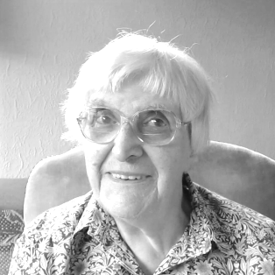
Our club President Stella Lamont celebrated her 89th birthday yesterday!

Stella was born on 1st September 1928 and has been involved with football for many years. In 2016 she received a long service award from the Surrey F.A.

Stella was first involved with Grove F.C., members of the Epsom & Ewell Youth League and took a regular interest in our club from 1973, becoming Press Secretary and also Programme Editor for many years.

We hope she had a great day!

Results Grid
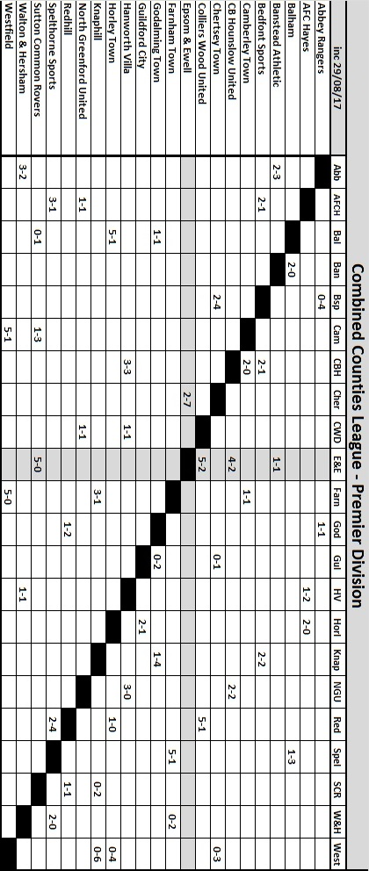

From behind the goal
Epsom & Ewell 2-7 Chertsey Town
Combined Counties League - Premier Division - Tuesday 15th August 2017

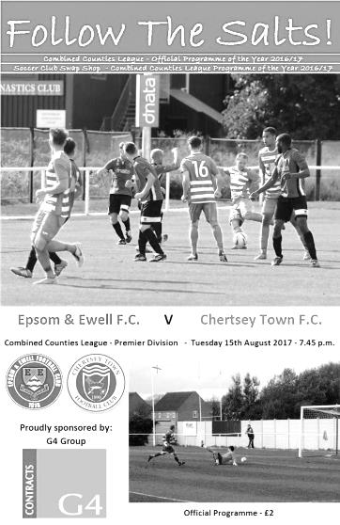
Chertsey fly past Salts with fine first half display

It was hoped that the 50th meeting of two local rivals would be a memorable occasion and it certainly was, but for all the wrong reasons as a Chertsey team that failed to score three days previously managed to find the Epsom net six times in the opening 31 minutes and cruised to an easy win.

In terms of records, this was the first time since 1936 that we had conceded six times in the first half of any competitive match and in truth, if it wasn't for some good saves from Colin Harris, our club record home defeat of 1-8 would have been in serious danger. The seven goals conceded was the first time we had done this since losing an F.A. Cup tie at home to Crowborough Athletic ten years ago this coming weekend and the 19th time in history it had happened.

The strangest thing about this match is that we appeared on paper to have a stronger team out than the one that had lost to CB Hounslow United on Saturday with Sam Robinson and Reisse Griffin back in the starting line-up and former Captain Jamie Hatfield starting in his old left back position after overcoming injury. However, it was clear that he was not fit, having sustained an injury in the warm up and he would be withdrawn inside 20 minutes, by which time the match was over as a contest.

The match started in a similar pattern to our last home encounter against Banstead Athletic as we conceded an early goal once again, this time after one minute and fifty seconds, only to go up the other end and equalise in the fifth minute when Joe Loftus-Cheek's shot went back across the keeper into the far corner. However, further goals after 8 and 11 minutes gave the visitors a cushion and provided Marcus Mealing with what might well have been the quickest ever hat trick against our team. His second goal was a clinical finish, while his third came after Bukele Mukudi's cross came back off our crossbar leaving an easy tap in.

Chertsey's fourth goal came after some good interplay and was finished off by Mukudi while Andy Crossley, who had scored the winner two seasons previously when Chertsey last defeated us, found the net in the 23rd minute with a low drive that went in off Harris' left hand post. The carnage was almost complete after Ben Dyson brought down his man as he cut in from the touchline and John Pomroy scored the latest goal of many against us as he stroked in the subsequent penalty.

It was clearly going to be one of those nights and the hard working Loftus-Cheek lobbed Chico Ramos in the Chertsey goal, only to see his attempt volleyed off the line by Ben Geraghty. Then Rob Hendry made good ground on the left only to see his low ball in roll straight under the foot of Kyle Hough! Hough nearly redeemed himself towards the end of the half with a shot from a narrow angle but Ramos blocked it out for a corner and Harris made a good save in first half injury time as we were caught out again.

Jason Nwachukwu replaced Jordan Brooks at the half and although Chertsey looked keen to increase their score, the game became more even. However, another goal was conceded in the 56th minute when the ball was crossed deep over to the left, where it was fed back in and volleyed into the net by Joe Jones. Dyson and Marvell joined Robinson in the book for fouls and we had the unusual sight of Cristian Castell substituting for the substitute Ben Hayward, something that had only happened eight times previously in an Epsom match!

There was no question Chertsey had been impressive, but in the 71st minute a very late challenge by Geraghty on Hough left our man in a heap on the floor. I've seen half a dozen photos of this incident since and in none of them is the ball even in shot, it was that late. Despite clearly being dangerous the referee decided quite wrongly that a yellow card was sufficient and then added insult to injury by handing out the same penalty to Hendry for a small tug of the shirt. When will referees learn that their number one priority out there is to protect players? Remember this when you see another game getting unnecessarily postponed later in the season on the grounds of player safety when it is "a little wet". From the free kick Castell saw his header saved from close range.

But this decision aside, we could have no complaints and sometimes in situations like this you find out who has the character to fight back. Loftus-Cheek certainly goes into that category and was brought down clumsily in the box as he threatened to shoot. For the first time ever with Hough on the field, it was Hendry who stepped up for the penalty in the 76th minute, but his two spot kicks for the club so far have been unstoppable and Ramos had no chance as we reduced the deficit to 2-7.

We finished well with Dyson's cross deflected for a corner, followed by another shot from Loftus-Cheek that was deflected wide, before Dyson had another shot from the edge of the box which looped up in the air off a defender, requiring Ramos to make an acrobatic dive to turn the ball around the post. However, the damage had been done in the first thirty minutes and with eleven goals conceded in our first two league matches it is only the number we have scored that keeps us off the bottom rung of the table after this result.

Epsom and Ewell: Colin Harris, Reisse Griffin, Jamie Hatfield, Franky Law,
Dale Marvell, Rob Hendry, Ben Dyson, Sam Robinson (c), Kyle Hough,
Joe Loftus-Cheek, Jordan Brooks

Subs: Ben Hayward for Hatfield (20), Jason Nwachukwu for Brooks (45),
Cristian Castell for Hayward (66)

#
From behind the goal
Sutton Common Rovers 5-0 Epsom & Ewell
Combined Counties League - Premier Division - Monday 21st August 2017

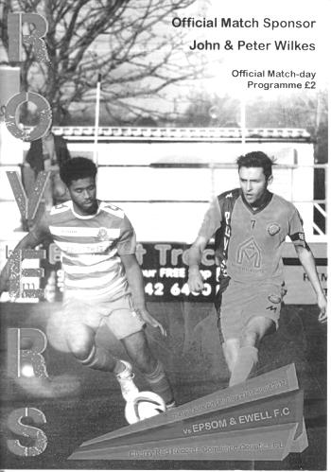
Salts defeated by former players

There have been times before in history when our club has lost a group of players to another team. In fairness this happens to most teams at our level at some point. In each case we have come through the other side, but it takes time.

Under the circumstances it was unfortunate that we had to visit Sutton Common Rovers so early in the season before our team had settled down and we fell to a heavy defeat at Gander Green Lane, their temporary home.

Until this match we had an excellent run against our opponents with nine wins and a draw in our last ten meetings. Our only previous loss had come way back in April of 2011 and what I didn't realise until reading the match programme was that one of their scorers that evening was Daryl Cooper-Smith. Fast forward just over six years and he was back in their colours, probably becoming the first substitute in their history to score a hat trick, although it has to be said that he will score few easier ones for this or any other club, due to a complete absence of marking in each case. It was almost as if we were unaware that he has come on at half time!

Bearing in mind that the other goals on the night came from another former player Craig Hastings, and an unfortunate own goal from Reisse Griffin, it meant that all five goals were scored by players who had worn the blue and white hoops last season. However, what would have been particularly frustrating for our Management was the way we had made this a competitive contest for the first 40 minutes. Although they shaded possession and chances the match had at least been fairly even for a while, but the second half display was incredibly disappointing for anyone connected with the Salts as we fell away quite badly.

We made four changes from the Chertsey defeat with the absent Franky Law, Jordan Brooks, Rob Hendry and injured Jamie Hatfield replaced by Ali Dewar, Jason Nwachukwu, Liam Roberts and Daniel Rose, with Dewar coming in at the unfamiliar right back position and Reisse Griffin partnering Dale Marvell at the back. The move was clearly meant to give us a bit more pace in defence, although it did also leave us a bit short of height and we would struggle all night with any deep deliveries. Again though, the reshuffle really highlighted the fact that we don't appear able to keep a settled team right now, which doesn’t help any attempts by the players to build chemistry and leaves our Manager extremely frustrated.

Despite doing more defending than attacking in the opening period, our keeper Colin Harris didn't have an enormous amount to do. A couple of long range shots were nearby but not on target, while Harris was out quickly to block former Salt Jordan Gallagher as he latched on to a deep cross. Joe Loftus-Cheek was close with a typical centre-forward's header from a deep Kyle Hough left wing cross on the half hour but the game was beginning to meander at this

point, which wasn't a bad thing, having let in six by this point in our previous outing.

All that changed as we conceded a soft goal after 42 minutes. A corner was delivered to the far post where Hastings was waiting, although his looping header didn't appear to have a great deal of power. However, Harris wasn't able to get to the ball, apparently impeded by one of our own players and somehow the ball fell over the line into the net. It was nearly two-nil right on half time when a low shot from a wide angle was deflected just wide of the post and into our side netting. On the balance of play it was hard to argue against the one goal lead, despite the unfortunate manner in which it had occurred.

We needed to fight back straight away and had our best chance of the night in the opening moments of the second half when a Sam Robinson free kick was delivered onto the head of Rose six yards out, but he missed the target by a distance and after 50 minutes it was 2-0 as yet another deep delivery was headed back by James Taylor for Cooper-Smith to head into an empty net from close range. Five minutes later he had scored again after everyone missed a low corner and he was able to again finish from a few yards out at the far post.

Rose responded with a twenty yard strike but Craig Bradshaw dealt with that comfortably and we then had a scare when the home team attacked down the right and although Dewar intercepted the low ball in his block appeared to cannon away off our own post. They had already hit the base of our post earlier in the second half from another far post delivery that was headed at goal and chances were beginning to come far too frequently. We changed things around with new signing Ashley Thompson coming on for Dewar and Tayo Ajayi taking the place of Roberts and this enabled Griffin to get forward. He had a shot blocked in the 71st minute after good interplay.

We had another concern as Marvell was dispossessed at the back, but the exposed Harris made a fine save from the one-on-one with the loose ball being drilled wide and the game begun to stretch again with Griffin's low cross inches ahead of Loftus-Cheek. Unfortunately Griffin put the ball in his own net in the 78th minute when trying to cut out a right wing cross with Cooper-Smith waiting nearby.

Harris made a great save in the 85th minute as he tipped a powerful shot over the bar but in the 89th minute Cooper-Smith completed his hat trick as he finished off a low Gallagher cross from close range. It was a familiar move which we had seen on a number of occasions for us last season and reminded us of how much more improvement is required this season if we are to compete with the other clubs in this league right now.

It is hard to say from just 90 minutes football whether Sutton Common Rovers raised their game in the second half or whether we fell away, allowing them to do so. In truth it was almost certainly a bit of both. Certainly nobody marked Cooper-Smith in the second half, although credit could also be given to our former striker for losing his man frequently. I think it's fair to say that we'll get a better idea of how both teams are getting on when we meet in the Surrey Senior Cup in November. Meanwhile we have to pick ourselves up for the Bank Holiday trips to Colliers Wood on Friday and Banstead Athletic on the Monday morning, well aware that we are now bottom of the league for the first time since 2006.

Epsom and Ewell: Colin Harris, Ali Dewar, Ben Dyson, Reisse Griffin, Dale Marvell, Daniel Rose, Liam Roberts, Sam Robinson (c), Joe Loftus-Cheek, Kyle Hough, Jason Nwachukwu

Subs: Tayo Ajayi for Roberts (66), Ashley Thompson for Dewar (66)

Club Records - 2nd September
Date | Day | Competition |  | Opponents |  | Scorers
02/09/33 | Sat | London League | A | Dagenham Town | 0-1
02/09/36 | Wed | London League Cup 1 | H | P.O.Engineers | 1-3 | L.Birch
02/09/59 | Wed | Corinthian League | H | Slough Town | 1-3 | M.Steadman
02/09/61 | Sat | Corinthian League | A | Letchworth | 3-2 | D.Mead, J.Punter, R.Walker
02/09/64 | Wed | Athenian League 1 | A | Horsham | 0-3
02/09/67 | Sat | Athenian League 2 | A | Wingate | 2-2 | A.Parrott (pen), C.Kelly
02/09/68 | Mon | Athenian League Div 2 Cup 1 | H | Worthing | 3-2+ | T.Yorke, A.Parrott, K.Jolly
02/09/72 | Sat | Athenian League Cup 1 | A | Aveley | 1-3 | B.Jones
02/09/78 | Sat | F.A. Cup Preliminary Round | H | Addlestone | 2-0 | G.Archer, T.Tuite
02/09/80 | Tue | Isthmian League 1 | H | Walton & Hersham | 2-0 | D.Walker, L.Peck
02/09/89 | Sat | F.A. Cup Preliminary Round | H | Met Police | 0-0
02/09/95 | Sat | F.A. Vase 1q | A | Horsham YMCA | 1-2+ | S.Miller
02/09/00 | Sat | F.A. Cup Preliminary Round | A | Moneyfields | 2-0 | G.Morris (pen), D.Marvell
02/09/06 | Sat | F.A. Cup Preliminary Round | H | Leatherhead | 0-2
Historical Decades
Date | Day | Competition |  | Opponents |  | Scorers
90 years ago – Epsom Town F.C.
27/08/27 | Sat | London League | A | Custom House | 4-2 | J.Parr, F.Behn, W.Challis, F.Watts
80 years ago – Epsom F.C.
04/09/37 | Sat | F.A. Cup  Extra Preliminary Round | H | RAMC Aldershot | 3-0 | H.Pullen (2), J.Jones (pen)
70 years ago – Epsom F.C.
06/09/47 | Sat | London League | H | P.O.Telecoms | 3-0 | W.Webber (2), F.Chitty
60 years ago – Epsom F.C.
04/09/57 | Wed | Corinthian League | H | Eastbourne | 4-2 | J.Bangs, B.Pickard, D.Hermitage, J.Sorensen
50 years ago – Epsom & Ewell F.C.
02/09/67 | Sat | Athenian League 2 | A | Wingate | 2-2 | A.Parrott (pen), C.Kelly
40 years ago – Epsom & Ewell F.C.
31/08/77 | Wed | Isthmian League 2 | H | Molesey | 4-2 | G.Butler, R.Parkin, S.Delaney, T.Tuite
30 years ago – Epsom & Ewell F.C.
05/09/87 | Sat | Isthmian League 2 South | A | Yeading | 1-3 | B.Perkins
20 years ago – Epsom & Ewell F.C.
30/08/97 | Sat | F.A. Cup Preliminary Round | H | Canterbury City | 0-1
10 years ago – Epsom & Ewell F.C.
04/09/07 | Tue | Combined Counties  Premier Division | A | Bookham | 1-1 | K.Hough (pen)

History Corner – 2nd September
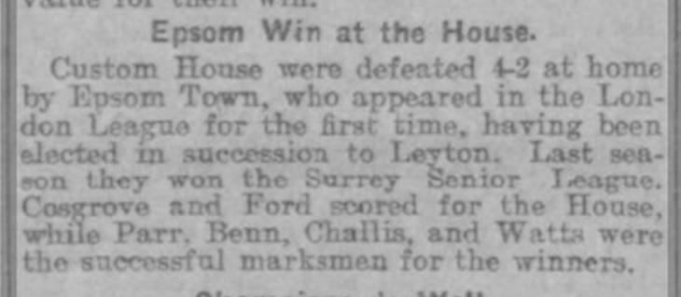
90 years ago this week we made our bow in the London League, having moved up from the Surrey Senior League following our League and Cup double the previous season.

We made what would be our longest ever journey to that point when visiting Bingley Road, West Ham, the home of Custom House for our opening match of the season and won fairly comfortably by four goals to two on what would prove to be our only visit, as they moved grounds later that season (see brief report above from the Chelmsford Chronicle).

What we didn’t realise at the time was that we would go on to win the League title at the first attempt, but more about that throughout the season.

80 years ago this week we defeated the Royal Artillery Medical Corps 3-0 in an F.A. Cup tie with a couple of goals from Jackie Pullen and another from Jimmy Jones, both of whom would become members of the elite 100 club, which to this day only contains just eight members. The run would end in the Second Qualifying Round with a 4-2 home defeat to Sutton United.

30 years ago this week we were the first visitors to Yeading’s Beaconsfield Road ground for their first ever Isthmian league match, narrowly being defeated 3-1 there. It would take a couple of years before they became a real force, earning promotion in 1989/90. Oh, and they won the F.A. Vase too that season. Ironically, we would win there that season!

20 years ago this week we played hosts at Merland Rise to Canterbury City in the F.A. Cup where a dreadful match was drifting to a goalless draw. Just as we were accepting our fate and looking towards a Tuesday replay at a new ground they spoilt the plan with a 90th minute winner and I never did get to visit their ground as it disappeared under housing a few years later. Canterbury still ground share to this day and are currently at Deal Town.

17 years ago today Dale Marvell scored his fourth goal for our club in a big 2-0 F.A. Cup win at Moneyfields, who play down in Copnor, near Portsmouth. Graham Morris had netted an earlier penalty as we qualified for a match against VCD Athletic. Dale now has 86 goals for us!

11 years ago today Leatherhead, with future keeper Paul Borg in goal came away from Merland Rise with a 2-0 win in the F.A. Cup. They would go all the way to the First Round, eventually being defeated at Plainmoor by Torquay United.

10 years ago this week Kyle Hough scored his first ever penalty for the club to secure a 1-1 draw at Meadowbank against Bookham. It only took him three seasons to smash the old record and he now has 55 successes from 59 attempts!

From behind the goal
Colliers Wood United 5-2 Epsom & Ewell
Combined Counties League - Premier Division - Friday 25th August 2017

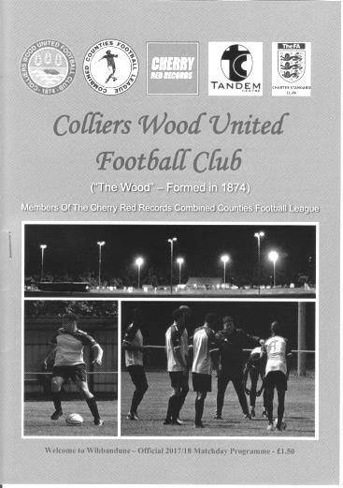
Lightning strikes twice at Wibbandune

One year ago we visited Colliers Wood United and were hammered 5-0. Fast forward 364 days and we suffered a similar fate once again as a skilful and pacey Wood eleven caused us all sorts of trouble and had the match won by half time.

Yet again we had to make more changes to the line-up after Monday's defeat with Colin Harris and Ali Dewar unavailable and Kyle Hough running late. In their place came Tayo Ajayi up front and in goal making his debut was Andy Smith. At left back we welcomed back Antony "Freddy" Myers and his inclusion moved Ben Dyson across to the right back slot. Finally, Ashley Thompson made his first start after a cameo substitute appearance on Monday and he played in defence, which moved Dale Marvell forward with Daniel Rose dropping to the bench.

We had started fairly well at Sutton Common Rovers before falling away and it was again imperative that we held our own in the early stages. Indeed Ajayi and Jason Nwachukwu both had shots blocked by defenders in the opening minutes, but the home team appeared well organised at the back and began to take control. Unfortunately they scored with virtually their first real attack which came across from right to left and was almost cleared but Theo Woodhouse won the ball back on the edge of the area and his low snapshot caught Smith out and went into the net off his outstretched arm in the 16th minute.

Then things started to go badly as the home side rose in confidence and began to spread the ball around nicely along both flanks. They nearly made it 2-0 with a shot into the side netting while we responded with a couple of long range efforts from Nwachukwu and Sam Robinson that were off target followed by another from Marvell, but a deflection took the pace off the shot and it went through comfortably to Jack Minchin in the Wood goal.

Most of the action was at the other end though and a fine run from right to left enabled Mohammed Mohammed to tuck in the loose ball from close range in the 27th minute before Alberto Lubango took centre stage for a while on the left. Aided by some dangerous overlaps from Daniel Hughes we were overloaded on that flank and Lubango darted around Dyson and Reisse Griffin but his lay back was wasted. Maybe frustrated by this he did it again moments later, this time drilling the ball into the net from a narrow angle on 35 minutes. Smith then made a fine save from a powerful shot from the right as we were pushed further and further back. This came to a head when Mario Embalo got away down the left and pulled the ball back for Woodhouse to drive in a fourth goal a minute before half time from nearly 30 yards.

Fortunately in the second half we were more competitive and pulled a goal back in the 49th

minute when Joe Loftus-Cheek fed the ball in to Robinson who put Ajayi through the middle. The otherwise impressive Cedric Abraham appeared to be in position to make the tackle but it didn't come and Ajayi flicked the ball over Minchin from just inside the area to open our account.

This goal appeared to annoy the home side who redoubled their efforts to regain the four goal lead and after a couple of narrow escapes they did just that after another tricky Embalo run left strike partner Eli Ogunseye with a tap in on 57 minutes. In response we were at least looking a little more dangerous ourselves when we had the ball and Liam Roberts did some good work on the right to set up the newly introduced substitute Hough but he was blocked out by a number of players.

It wasn't long before we were back on the defensive though and a long range strike flew back of the joint of bar and post in the 64th minute with Smith beaten. Then there was then a penalty shout at each end in the space of a minute, firstly when a Wood striker appeared to be sandwiched, although the referee, in a good position, indicated that we had won the ball fairly. Then on the break Kyle Hough was shoved off the ball by a defender as they both chased for it. Personally, I thought that this was over and above the standard shoulder charge, but it was one of those that you would get in the middle of the park but not in the area and the claims were waved away.

Robinson had a low shot deflected in the 76th minute after some good play on the right but Minchin did well to deal with the shot which notably changed direction, before the hosts caught us out with a quick free kick for a foul by Myers, but the free header was somehow put wide of Smith's left hand post. Louis O'Brien came on for his debut in relief of the injured Ajayi and he combined well with Griffin to win a corner but we were unable to make the delivery count. Still, we did score again in the 90th minute as the home side pushed up and a ball over the top set Hough through in the right hand channel. He ran in on goal and finished clinically into the far corner as he so often does to leave Minchin helpless and make the final score 5-2.

It may have been only a small crumb of comfort to win the second half 2-1 but it was an improved second forty-five, even though the home team wasted a number of chances in the second half. While that continues, they cannot be considered title contenders. However, if they can find a way to take more of the numerous opportunities they create then they have every chance of a top four finish as they were the best team we have played so far this season and will give other teams nightmares at the back also.

For our part 5-2 brings the tally up to 21 goals conceded in the four League games to date, but changes are afoot and it is hoped we will see a number of new faces around for the League meeting at Banstead Athletic on Monday morning. I remain convinced that we can get out of trouble quickly if we can find a bit of defensive stability. It is a rather large understatement to admit that this is not a word that can be used right now.

Epsom and Ewell: Andy Smith, Ben Dyson, Antony 'Freddy' Myers, Ashley Thompson, Reisse Griffin, Dale Marvell, Jason Nwachukwu, Sam Robinson (c), Tayo Ajayi,
Joe Loftus-Cheek, Liam Roberts

Subs: Kyle Hough for Dyson (55), Daniel Rose for Roberts (69),
Louis O'Brien for Ajayi (82)

From behind the goal
Banstead Athletic 1-1 Epsom & Ewell
Combined Counties League - Premier Division - Monday 28th August 2017

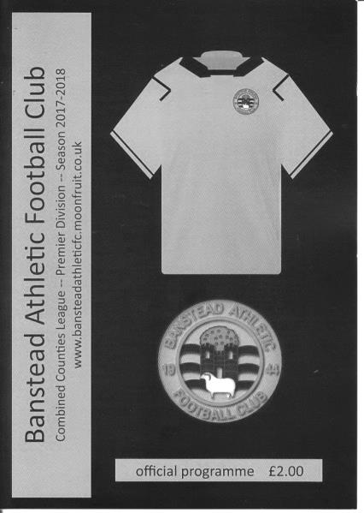
Salts open account at the fifth attempt

It may have taken five League matches but we are up and running after earning our first point of the season at Banstead on Monday morning.

Following the defeat at Colliers Wood United Colin Harris returned between the posts and the returning Scott Murphy made his first appearance for us since April 2007 at the back, pairing up with Captain Ben Hayward. The increasingly versatile Ben Dyson moved back from right to left back with Reisse Griffin on the right, while in midfield Louis O'Brien made his first start alongside Daniel Rose with Sam Robinson away and Dale Marvell on the bench. Up front Kyle Hough started in place of Tayo Ajayi who was injured on Friday.

Having had such a poor start to the season it was easy to forget that Banstead were also looking for their first league point, following a 2-0 reverse at Balham on the Saturday and they started the stronger of the teams. In fact there was a bizarre sequence of events as early as the ninth minute which was almost impossible to report. Suffice to say that the ball pinged around in our own area for what seemed an eternity before an opposition player drilled the ball straight into the arms of Harris from close range when it seemed easier to score!

In response O'Brien tried his luck from 25 yards but didn't have the power in the shot. He rectified this moments later when running on to a nice pass from Joe Loftus-Cheek but his strike was tipped over for a corner. From the set piece, the ball in had too much height for Kyle Hough and he was only able to get a slight touch to it. In the 16th minute O'Brien put Jason Nwachukwu through but his shot was well saved by the Banstead keeper from eight yards.

The first twenty minutes had gone fairly well so far but the home side began to assert themselves a little more from that point and shaded the rest of the half. A short corner was volleyed just over the bar on the half hour, before a late block was just enough to divert a Banstead strike for a corner. For our part we had a penalty shout turned away when Hough was taken out by a defender's shoulder charge. It was well away from the ball and could well have been given but not this time. On 41 minutes though we had

the best chance of the match when Nwachukwu's perfect cross dropped right onto the head of Rose, but instead of heading the ball at goal he held back and tried to volley it instead with minimal contact; the shot dribbling towards the grateful keeper.

The home side finished strongly after this and we had to block a close range shot over the bar, before another low attempt from fully thirty yards just missed Harris' left hand post.

So, for the first time this season we had recorded a clean sheet in a half. The second half looked like it would be a tough one though as they came out and pushed us back. Harris made a good low save but could do nothing about a powerful strike from nearly thirty yards that thudded against our left hand post and away to safety.

From the clearance though, we took the lead after Griffin had made good tracks down the right wing and his cross was met by a good header on target from Rose. Somehow their keeper blocked it from close range but the incoming Hough swivelled to volley the loose ball into the top corner of the net in the 50th minute.

In response their danger man Leo Medrado went on a mazy run but Harris and his defenders crowded him out and the game began to drift a little. Nwachukwu was high with a free kick awarded for a foul on the returning Sean White who had by now entered the fray, but just as we were starting to look at the possibility of climbing off the foot of the table, the hosts equalised. With the clock showing 86 minutes we conceded a corner after failing to deal with a long throw and from the set piece to the near post Harris was unable to clear the ball which was then hooked back in to the danger area and forced into the net from close range by Owolabi Tunde.

A number of minutes remained in the match due to stoppages for injuries and water breaks (one of which had even appeared to include an impromptu team meeting for the opposition!) and in that time both teams tried to get a winner.

Sean White headed a Nwachukwu corner over from a difficult angle before the home side really should have won it in the 98th minute with a good move that ended with a shot over the bar from well inside the box, but the final whistle blew soon after to give both teams a point, although neither will have been particularly happy with it on reflection.

Still, it is nice to finally get off the mark and the defensive situation improved today with Murphy looking comfortable and Hayward settling down after a couple of errors in the opening twenty minutes. In fairness though Hayward was unable to even come off the bench on Friday, so after 90 minutes in the stifling heat he set a fantastic example of the sacrifices that need to be made if we are to move away from the foot of the table.

Epsom and Ewell: Colin Harris, Reisse Griffin, Ben Dyson, Ashley Thompson,
Scott Murphy, Louis O'Brien, Ben Hayward ©, Daniel Rose, Kyle Hough,
Joe Loftus-Cheek, Jason Nwachukwu

Subs: Dale Marvell for O'Brien (55), Sean White for Loftus-Cheek (73)

Every Opponent A-Z
Over the years we have played many, many different opponents. Exactly how many is a difficult question, as it all depends on your definition. Are Camberley & Yorktown different to Camberley Town, or are Epsom Town different to Epsom F.C. or Epsom & Ewell F.C.?

In my analysis I have classed both of the above examples as the same team, and will work through them all from A to Z. Some we have played many times, whilst others we have met just once or twice. Enjoy!

Watford Old Boys: Played 1 - W0 D0 L1 - F2 A4 - PPG - 0.00

As our first season of senior football drew to a close in 1924/25 a few friendlies were arranged. Two were against well-known local rivals Sutton United while the lesser known Watford Old Boys were visitors to the Horton Hospital Sports Grounds on 28th March 1925.

Why a team from Watford would come over to Epsom is unclear, although our Trainer at the time, Committee member G.E.Elmslie had previously been with Watford so there may have been a connection as he certainly knew many famous players of the day. Anyway, we trailed 2-0 before levelling the score, only to fall away to lose 4-2 in the end. We never met again.

Wealden: Played 1 - W1 D0 L0 - F3 A1 - PPG - 3.00 - Perfect

Wealden played at a very picturesque fir tree lined ground in Uckfield, East Sussex and we visited for an F.A. Cup tie on 15th August 2009. We completely dominated the match against our Sussex League opponents but conceded after about 15 minutes and as the game went on things were beginning to get very concerning. Fortunately, with less than ten minutes remaining Richard Webber sent in a cross and everyone missed it; the ball nestling in the far corner.

Late goals from Robbie Burns and a beauty from Ramzi Bedj Bedj gave us the 3-1 scoreline that we deserved. However, our luck would be well and truly out in the following round as we lost 1-0 to ten man Selsey in what remains one of the more disappointing matches in our recent history. On reflection, it might have been better to have lost at Wealden and saved the petrol!

Wealden changed their name to AFC Uckfield a few years later and then absorbed the smaller Uckfield Town but they remain a Step Five team to this day, still at their fir tree lined ground.

Wealdstone: Played 7 - W2 D1 L4 - F9A11 - PPG - 1.00 - Poor

Many will remember a spell in the nineties when we met Wealdstone but few will know that we first met on 18th December 1937 at their famous Lower Mead home for a London Senior Cup tie. They were a powerful Athenian League team and unbeaten at home, but goals from Tommy Rochester and Brian Beglan gave us a 2-0 win.

Or so we thought! Wealdstone protested on the basis of the residential status of Rochester, and even though he had played for us for over a season by this point, the London F.A. ordered a replay. Two weeks later on New Year’s Day we were edged out, again at Lower Mead by three goals to two, although we were somewhat preoccupied by the accident a few days later that would claim the life of former club legend and original player Jack Parr.

Our next matches didn’t come until 1995/96. Wealdstone had by then lost their ground and were sharing at Edgware’s White Lion, having also switched from the Southern League side of the Pyramid to the Isthmian, which in those days required them to start at Division Three and work their way up, which they eventually would.

The old Wealdstone ground at Lower Mead, complete with main stand which was taken from Summerstown’s old ground at Earlsfield Road when they folded in 1927. It survived for over 60 years before being demolished with the ground in the mid-nineties

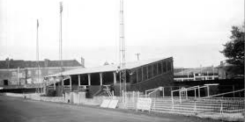
It wouldn’t happen immediately though and they failed to earn promotion in their first season, finishing fourth well behind Horsham, Leighton Town and Windsor & Eton. The first meeting for nearly sixty years came on 16th March 1996 and resulted in a 1-1 draw after Stuart Miller had put us ahead. We lost the return at Merland Rise in the April by two clear goals and were edged out by the odd goal in both matches of the 1996/97 season when Wealdstone did finally clinch promotion, by now with Miller in their ranks.

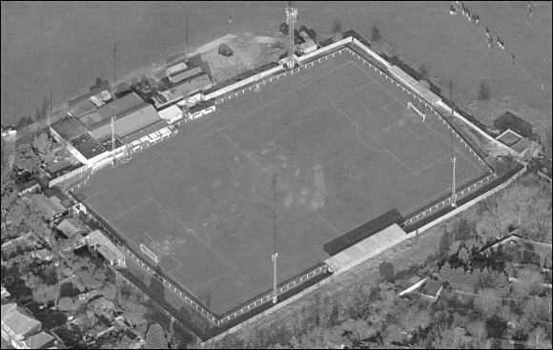
However, we would get the last laugh. The following season we had a great run in the Associate Members Trophy, defeating Bracknell, Windsor & Eton and Marlow, all from Division Two before being paired in the Semi-Final at Wealdstone. An Andy Rawlinson goal secured the 1-0 win at the White Lion on 17th March 1998 to claim a fourth scalp from the higher division, and even though we were unable to defeat Bedford Town in the Final to make it five, it remains a famous victory against a team with a much larger fan base and resources.

Since then attempts to build a ground stalled at an area now known as the Hive and used by Barnet, but soon after this they jumped into Ruislip Manor’s Grosvenor Vale ground magpie style, saw off the smaller club and have now been there for over a decade, currently playing at Step Two in the National League South after gaining promotion as Champions in 2014.

Grosvenor Vale as it now looks these days

Centre page for results

Centre page for results

Redhill F.C. – History
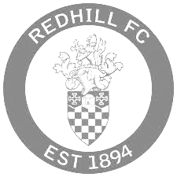
Redhill Football Club is steeped in a rich history and prides itself on tradition.

It all started for the club back in 1894, after a meeting between prominent local businessmen in the Warwick Hotel and shortly after, a friendly match was arranged against a Dorking side. That game ended in a two all draw and was played at the clubs original home at Wiggie. A ground lent to the club by their goalkeeper, Mr. H Trower.

Two years later, the club moved into its stadium of 88 years at Memorial Park in the centre of Redhill. At the time, the ground was an open swamp, until proper drainage was installed, which was accomplished under the auspices of a Sports Ground Association, an organisation that lasted until 1919.

For the first few years, the club only competed in friendly matches but that all changed in 1898, when Redhill Football Club entered the South Suburban League, followed by various other leagues that have since folded.

It didn't take long for the Reds to make an impact; The club were Champions of the East & West Surrey league in 1902/03, and two years later, lost in the Surrey Senior Cup final.

THE 'GLORY' YEARS

In 1922, the club gained acceptance to join the prestigious London League, which acted as a stepping stone for the club, when they became members of the Athenian League. Success came early in the Athenian League, finishing runners up in their first season, and becoming champions in 1924/25.

The following year, the club enjoyed what was possibly its best season ever, reaching two cup finals and the semi-final of the FA Amateur Cup, losing 7-1 to Northern Nomads at Highbury in front of 17,000 people. A possible contribution to the final result of that game was the fact that Redhill lost their goalkeeper very early on with a severe jaw injury.

CRIES OF 'REDHILL'

In fact that game sparked off an unusual football tradition that can still be heard today. Without a 'keeper and down to 10 men, Redhill were reduced to kicking the ball out the ground every time the Nomads attacked and each time, a cry of "Redhill!" was screamed by the supporters of both sides.

Over the years this spread around the entire country as both Redhill and the Nomads travelled the land, and when war broke out in 1939, the troops took it abroad. Next time you're at a game, anywhere in the world and the ball is booted out of the stadium, you might just hear someone shout "Redhill!"

In 1928/29, Redhill won the Surrey Senior Cup with a 3-2 over Epsom Town (who later became Epsom & Ewell). The match was played at Josephs Road, Guildford in front of four thousand, six hundred people.

Redhill, despite being a non-league side, were once one of the most feared teams in the south of England. Non-league football was a completely different game in years gone by, and gap between the amateurs and the professionals was much smaller than it is today.

In April 1948, Redhill faced Chelsea in a friendly match at the memorial sports ground and the Reds came away as 4-2 winners. Of course, Chelsea weren't the force that they are now, but they did field an English International by the name of Len Goulden. When this match took place, Redhill were bottom of the Athenian League.

A year later, Redhill lost 1-0 against Arsenal. The match was friendly offered by the London side in return for Redhill providing the Gunners with two of their most talented players at the time; Colin Grimshaw and Bernard Sexton. Grimshaw also spent time with Epsom.

Further success was a long time coming, but it was well worth the wait, in 1957/58, the club reached the 1st round proper of the FA Challenge Cup. They defeated Tooting & Mitcham in the 4th qualifying round and were rewarded with a trip to Carrow Road against Football League side, Norwich City. The Canaries came out as 6-1 winners, but many write-ups at the time gave Redhill lots of credit for the manner of their performance.

In the 1960's, A very talented youngster by the name of Ray Hutchins played for Redhill. Not many people in football circles will know the name, but in 1963/64, he won two England youth caps whilst playing for Redhill. The other players in the squad were playing for top professional clubs, and one of players was a certain Harry Redknapp playing at the time for West Ham United.

During the 1970's, the club was inconsistent in the Athenian league. League placings of 6th, 10th, 7th, 2nd to bottom, 12th, 10th again, 12th again, 11th, Bottom, and second to bottom completed the decade.

THE END OF AN ERA

As the Athenian League drew to a close in the early 80's, so too did Redhill football clubs home. The 1983/84 season saw Redhill win the last ever Athenian League title, but the club were unable to take their place in the higher league, Redhill were asked to move out of the Memorial Ground and move to a site two miles south, to Kiln Brow, where facilities were non-existent. (Memorial Ground pictured below)

The area once known as the Memorial sports ground remains as an open park space but if you know where to look, you can still see evidence of where the main stand was situated.

The club took their place in the London Spartan league, but times at Kiln Brow were tough. Samples taken at the time have shown that the soil on the pitch was made up of more clay than actual soil. So much so, that even worms couldn't live in it! But the club battled on with ups and downs and over the years, the hard work of many individuals has kept the club alive.

In July 2007, non-league legend Tommy Sampson (who won the last old Wembley F.A. Vase final with Deal Town) was appointed Manager with former Kingstonian and Bromley Manager Stuart McIntyre becoming 1st Team coach. Half way through the season though, Tommy unfortunately suffered a stroke and Stuart McIntyre took over first team affairs with the help of Jeremy Jones. The team reached the semi-finals of the Sussex RUR Cup and the Surrey Senior Cup. In October 2008, McIntyre decided to step down and take on a less demanding role due to personal and work commitments. The club appointed former Brighton & Hove Albion player, John Crumplin as manager and McIntyre stayed on as his assistant.

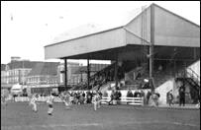
A new 162 "Alan Thurlbeck" stand, with facilities for disabled fans was built in the summer of 2008 and work continues on the development of the ground with new turnstiles and a new outside toilet block.
In 2009/10 former Epsom and Ewell and Redhill player Marcus Alcindor became Manager, leading the club to 5th place in the Sussex League for the 2009/10 season.

Another change in management the following season saw Steve Johnson take over half way through, but with a handful of games left to play, he too parted company with the club paving the way for another man to take over the reins.

Simon Colbran's time as Redhill manager was short lived, and Michael Maher, Redhill's youngest ever manager, moved up the ranks from Youth Team manager to First Team manager in early 2012. He took the club up to the Ryman League in 2012/13 where they remained for two seasons before being relegated with Maher sacked. However, their first season in the Combined Counties League started badly and the new Manager Perry Gough resigned with Maher returning in a caretaker role. However, the damage was done and Redhill went down, only to bounce back as runners-up last season.

Previous Matches against Redhill
We have played Redhill on 33 occasions in our history and many of these matches were significant ones as we were rarely in the same League, so would meet as local rivals in the F.A. Cup, Amateur Cup and County Cup, often watched by thousands of spectators before the war.

The first time we ever met was over 90 years ago, on 15th November 1924 for an Amateur Cup tie. It was our first ever season in the competition, but despite beating West Norwood to reach this stage, Redhill were far too strong, triumphing easily 5-0. The game was an Epsom home game, but it had to be switched to Redhill because the Horton Sports Ground did not allow the Blues to take a “gate”.

The following year they met at our new ground at West Street in the East Surrey Hospital Cup, but Redhill still won easily 8-2. In March 1928 Epsom gained revenge 7-2 in the same competition, the first defeat Redhill had ever suffered in its eight-year history. However in November of the same year they had defeated us 2-1 in the Surrey Charity Shield at the Memorial Ground, despite a goal from Herbert Etheridge.

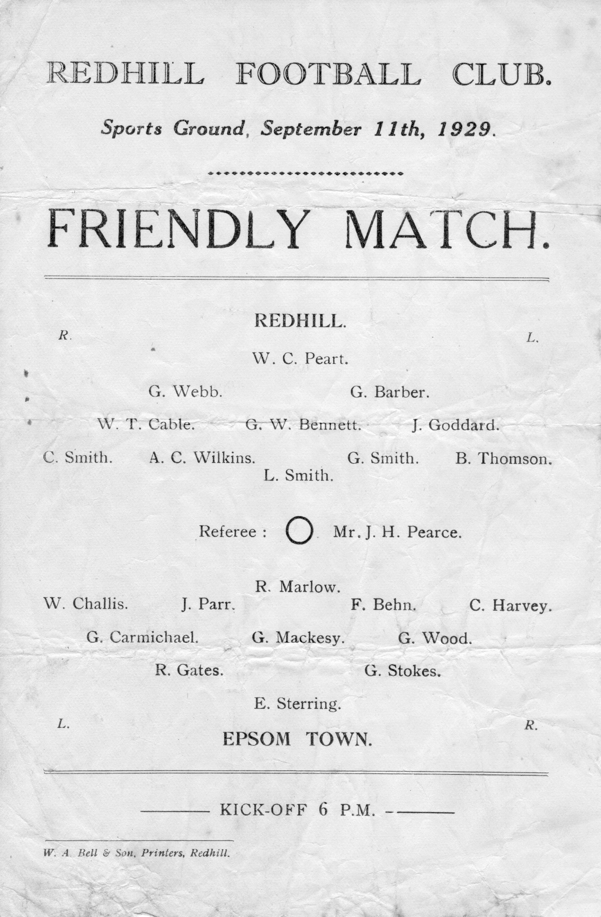
The Surrey Senior Cup Final of 1929 at Guildford City’s Josephs Road ground was a big game and was watched by 4,600 interested spectators and we led at half time through our left winger Wilfred “Bronk” Challis, but three goals in a ten minute spell, the first of which was a harsh penalty, left the Blues too much to do, and although Bob Earl reduced the deficit with fifteen minutes to go, it was too much to retrieve.

We lost a friendly there in the September of 1929 (see programme left) and Redhill defeated us again a month later as our Amateur Cup run ended at a familiar hurdle. All in all, the Lobsters would knock us out of this competition on eight occasions, while we won just three of the ties. The first of these was in a final qualifying round Amateur Cup tie that we

won 2-1 on 21st November 1931 at Redhill in front of 4,000 with goals from Leslie Graves and Harry Payton (see programme right).

That win earned us a visit to the First Round Proper where we would travel to and defeat Ipswich Town 4-2 but that story is for another day!

The win turned fortunes around in these meetings and after losing six of our opening seven contests, we now embarked upon a run of our own, containing five wins and a draw from the next six.

The next of these came on 1st October 1932 in the F.A. Cup when two goals each from Tommy Dunne and Billy Williams, three of which came in the second half, ensured a 4-1 win at West Street.

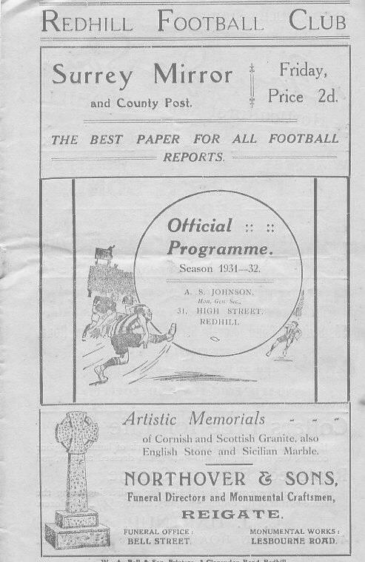
Almost one year on we repeated the scoreline in the Amateur Cup, this time with Leslie Marlow scoring a hat trick in front of just under 3,000 spectators at West Street. The most I ever saw at West Street was 1,800 and the ground was packed, so I’ve no idea how 3,000 or sometimes even more could have got in there and actually been able to see the match too!

The following season we travelled there in the F.A. Cup where on 15th September 1934 we defeated them 6-3. Unfortunately our attempts to reach the First Round of the F.A. Cup for the second season in succession were thwarted by Guildford City a couple of rounds later.

However, we made it a double of sorts by then knocking them out of the Amateur Cup by three goals to one, following a 1-1 draw at the Memorial Ground in the November, with Tommy Dunne on target in both matches.

But all good runs have to end and in 1935/36 we were not such a good team. We had recorded a club record 13-1 win over Reigate Priory in the Amateur Cup but Redhill

knocked us out 2-0 at West Street in the following round with a goal in each half.

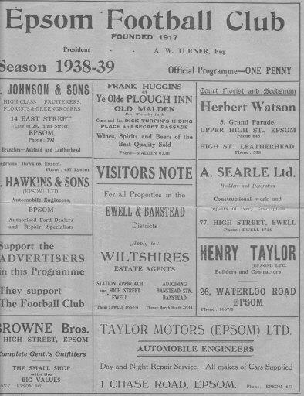
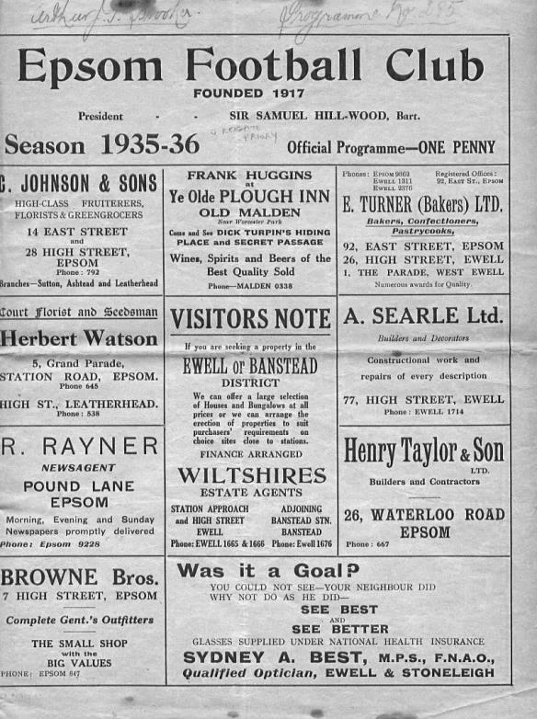
They then repeated the score line later that season, again at West Street in the Semi-Final of the Surrey Charity Shield (see programme left)

Heavy Amateur Cup defeats followed in 1936/37 and 1937/38 by three clear goals at Redhill and 4-1 at home in the later match. The tide had turned against us and although we were a decent side again by that point, the Lobsters as they were better known back then, were stronger.

A goalless first half at Redhill on 11th December 1937 turned into a 4-2 Surrey Charity Shield loss and by the time of the 1938/39 season

we marked our sixth straight meeting in the Amateur Cup with a narrow 2-1 home defeat after extra time; the opening 90 minutes having failed to produce a goal. (see programme right). Then one week later they returned to knock us out of the F.A. Cup too, this time by the more decisive score of 4-1.

Maybe thankfully this was the last time that the two teams met before World War Two ensured little contact, although the Epsom Town team that rented West Street for the duration of the hostilities did meet them twice in our inaugural season in the South Eastern Combination, although the wins that each home team procured were futile as Redhill withdrew from the league in November 1940.

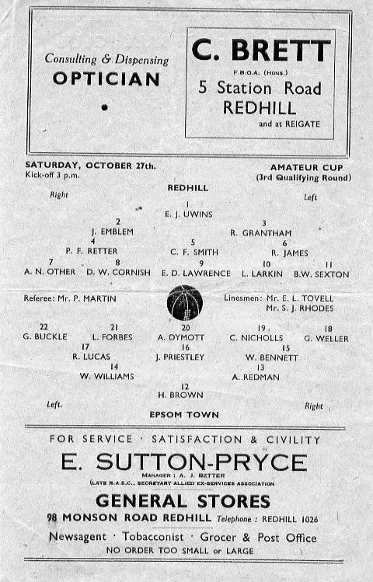
Upon resuming football we defeated them home and away in friendly challenge matches during 1945/46 but once we were back into the big matches, we were found lacking, and 3,000 people watched us get beaten 5-0 at the Memorial Ground in the Amateur Cup on 26th October 1946, even though the programme had the date wrong and the round of the competition too! (see programme right)
Further defeats followed. Another Surrey Charity Shield defeat came our way on 20th March 1948, albeit narrowly, 2-1 after extra time, and we then had to wait seven years for our next meeting in the Final Qualifying round of the Amateur Cup. Despite our previous two wins at this stage we were edged out 2-1 at the Memorial

Ground despite Dave Hermitage’s second half goal we were unable to equalise, having trailed by two goals at the half in front of 4,000 spectators. (see programme left)

This would be our last meeting for many years. Maybe the geographical boundaries changed but it seems bizarre that after meeting so frequently in previous years that it would be nineteen years before we would again meet.

Of course, part of the reason for this was that Redhill had an exemption in the Amateur Cup, while we were a much poorer side throughout the sixties and early seventies so were usually out before they had joined the competition!

Our next meeting, also in the F.A. Cup, ended in defeat, despite the fact that we were a very good team that year. The 1974/75 season will be remembered for many things but it won’t be for our F.A. Cup run as we may have started our season off with eight straight league games with a goal difference of F26 A1 but this didn’t bother Redhill, and although later in the season we would beat other teams from their division in our famous Vase run, we were no match this day and crashed 3-0.

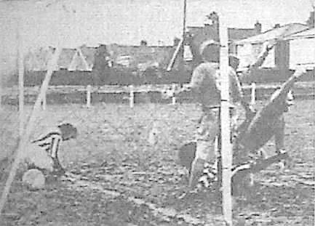
We were on the rise by that time and eventually found ourselves promoted into Redhill’s division for the 1976/77. After all these years we were finally at the same level and we drew 2-2 over there before winning 1-0 in the return on New Year’s Day 1977 with former Redhill player Alex Reid scoring our goal. (see below)

In between that we also won a Surrey Senior Cup tie at Redhill in December 1976 by five clear goals and so it transpired that on our last visit to the Memorial Ground we recorded our biggest ever victory there.

Along with many clubs at the end of the season we were accepted into the Isthmian League, but in the first sign of concern about their ground, they were not accepted, despite finishing in midtable. In 1984 they won the Athenian League in its final season but were again unable to follow the majority of its clubs into the Isthmian League due to the loss of their ground that season and since that time they have been at Kiln Brow; a very basic ground in its early days, although much better appointed now.

They had to spend time kicking around in the London Spartan League and then in 1987 moved into the Sussex League, where they remained for a number of years. During that

time we met twice more in the Surrey Senior Cup, on 23rd October 2001 and on 20th January 2009. Both matches were played at our home ground of the day, Merland Rise and both were won 3-0 with one goal in the first half and two in the second!

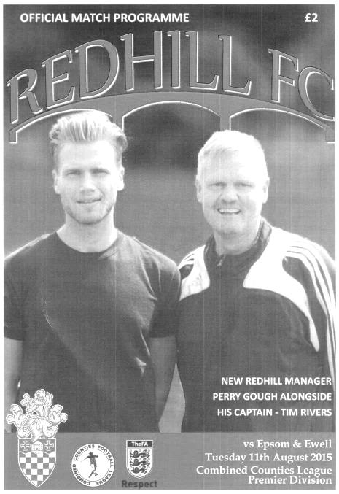
This brings us almost up to date. Redhill finally achieved their membership of the Isthmian League in 2013, although two seasons at that level culminated in relegation to our league and we became their opening visitors back on 11th August, taking the points thanks to a second half Kyle Hough strike. (see programme left)

We then followed that up with a 3-0 win in our last meeting at High Road in February 2016 and Redhill were relegated that season.

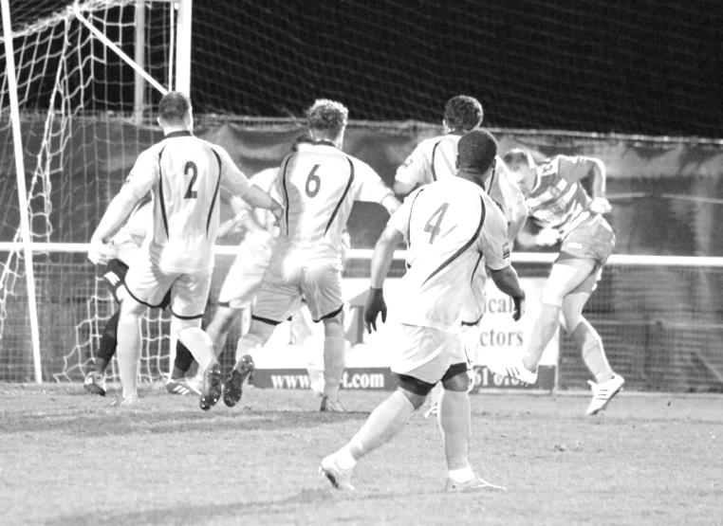
Now they have bounced back up to Step Five and it is possible that we will see a lot more of each other over the next few years, starting today. Although we will surely never again have meetings watched by the numbers that used to attend years ago when the two teams used to be regular rivals, it remains a local derby with a substantial amount of memories!

Kyle Hough opens the scoring in our last meeting; a 3-0 home win on 2nd February 2016. There is a ball in there somewhere!

Match and Ball Sponsorships – 2017/18
Opponent | Date | Match Sponsor | Ball Sponsor
Banstead Athletic (FAC) | 06/08/17 | Club President - Stella Lamont
Chertsey Town | 15/08/17 | EEFC Management Committee
Redhill | 02/09/17 | Building Shop Ltd
Spelthorne Sports | 09/09/17
Horley Town | 12/09/17
Hanworth Villa | 23/09/17
North Greenford United | 28/10/17
Godalming Town | 11/11/17
Farnham Town | 14/11/17
Guildford City | 02/12/17
Abbey Rangers | 16/12/17
Walton & Hersham | 30/12/17
Balham | 20/01/18
Sutton Common Rovers | 03/02/18
CB Hounslow United | 13/02/18
Knaphill | 24/02/18
Camberley Town | 10/03/18
Bedfont Sports | 24/03/18
Colliers Wood United | 30/03/18
Banstead Athletic | 02/04/18 | Nathan Lambert – 10 years old today!
Westfield | 14/04/18
AFC Hayes | 28/04/18 | Club President - Stella Lamont
F.A. Vase 1st Round Proper |  | Unknown opponents
For League, League Cup and Surrey Senior Cup Matches:
Match sponsorship - £40.00 Match ball sponsorship - £25.00. Combined £55.00.
For F.A. Cup and F.A. Vase matches:
Match sponsorship - £50.00 Match ball sponsorship - £30.00. Combined £65.00.

Sponsorship includes: (x2 for match, x3 for match and ball)

Admission, programmes, hospitality and advertising and mascot for the day (if required).
If you are interested, just speak to a Committee Member, or drop me an email at: richard.c.lambert@gmail.com

We also thank our Kit Sponsors
G4 Group

Combined Counties League Premier Division
Opponents All-time Records
Inc Monday 28th August | P | W | D | L | F | A | PPG | GD | Best  Win | Worst  Loss
Godalming Town | 1 | 1 | 0 | 0 | 2 | 1 | 3.00 | +1 | 2-1 | -
Spelthorne Sports* | 7 | 5 | 2 | 0 | 15 | 6 | 2.43 | +9 | 6-2 | X
Horley Town | 30 | 21 | 5 | 4 | 67 | 31 | 2.27 | +36 | 6-0 | 1-3
Abbey Rangers | 4 | 3 | 0 | 1 | 11 | 4 | 2.25 | +7 | 7-1 | 2-3
Sutton Common Rovers | 13 | 9 | 2 | 2 | 30 | 19 | 2.23 | +11 | 4-0 | 0-5
Bedfont Sports | 11 | 7 | 2 | 2 | 21 | 12 | 2.09 | +9 | 5-1 | 0-4
Banstead Athletic | 38 | 23 | 7 | 8 | 62 | 38 | 2.00 | +24 | 5-0 | 0-4
Knaphill | 8 | 5 | 1 | 2 | 17 | 9 | 2.00 | +8 | 4-0 | 1-2
Guildford City | 18 | 11 | 1 | 6 | 35 | 22 | 1.89 | +13 | 5-1 | 1-5
Westfield | 21 | 12 | 3 | 6 | 43 | 36 | 1.86 | +7 | 6-1 | 0-4
Colliers Wood United | 24 | 14 | 2 | 8 | 47 | 39 | 1.83 | +8 | 4-0 | 0-5
Farnham Town | 15 | 8 | 3 | 4 | 27 | 25 | 1.80 | +2 | 3-1 | 1-4
Hanworth Villa | 17 | 8 | 4 | 5 | 38 | 27 | 1.65 | +11 | 5-0 | 1-4
Walton & Hersham | 52 | 25 | 11 | 16 | 105 | 99 | 1.65 | +6 | 8-0 | 1-9
Camberley Town* | 90 | 38 | 22 | 29 | 158 | 125 | 1.51 | +33 | 9-1 | 0-4
Windsor | 50 | 20 | 12 | 18 | 92 | 90 | 1.44 | +2 | 4-0 | 0-6
Redhill | 33 | 14 | 2 | 17 | 63 | 69 | 1.33 | -6 | 7-2 | 2-8
Chertsey Town | 50 | 19 | 5 | 26 | 77 | 94 | 1.24 | -17 | 3-0 | 0-7
North Greenford United | 12 | 4 | 2 | 6 | 18 | 22 | 1.16 | -4 | 3-0 | 1-4
AFC Hayes | 10 | 2 | 3 | 5 | 18 | 18 | 0.90 | 0 | 7-0 | 0-3
CB Hounslow United | 4 | 1 | 0 | 3 | 6 | 11 | 0.75 | -5 | 2-0 | 1-5
Balham | - | - | - | - | - | - | - | - | - | -
* includes one abandoned match v Camberley and one loss on penalties v Spelthorne

Ryman League Division One South Table
incl Monday 28th August | P | W | D | L | F | A | Pts | GD
Walton Casuals | 4 | 4 | 0 | 0 | 12 | 5 | 12 | +7
Carshalton Athletic | 4 | 3 | 1 | 0 | 10 | 4 | 10 | +6
Whyteleafe | 4 | 3 | 1 | 0 | 9 | 3 | 10 | +6
Lewes | 4 | 3 | 1 | 0 | 6 | 3 | 10 | +3
South Park | 4 | 3 | 0 | 1 | 13 | 4 | 9 | +9
Cray Wanderers | 4 | 2 | 2 | 0 | 9 | 2 | 8 | +7
Sittingbourne | 4 | 2 | 2 | 0 | 7 | 3 | 8 | +4
Thamesmead Town | 4 | 2 | 1 | 1 | 10 | 6 | 7 | +4
Greenwich Borough | 4 | 2 | 1 | 1 | 6 | 3 | 7 | +3
Hastings United | 4 | 2 | 1 | 1 | 6 | 5 | 7 | +1
Phoenix Sports | 4 | 2 | 1 | 1 | 5 | 4 | 7 | +1
Corinthian Casuals | 4 | 2 | 0 | 2 | 9 | 6 | 6 | +3
Herne Bay | 4 | 2 | 0 | 2 | 6 | 5 | 6 | +1
Horsham | 4 | 2 | 0 | 2 | 6 | 8 | 6 | -2
VCD Athletic | 4 | 2 | 0 | 2 | 8 | 11 | 6 | -3
Molesey | 4 | 1 | 1 | 2 | 4 | 8 | 4 | -4
Faversham Town | 4 | 1 | 0 | 3 | 9 | 9 | 3 | 0
Guernsey | 4 | 1 | 0 | 3 | 6 | 7 | 3 | -1
Hythe Town | 4 | 1 | 0 | 3 | 6 | 7 | 3 | -1
Ramsgate | 4 | 1 | 0 | 3 | 5 | 10 | 3 | -5
East Grinstead Town | 4 | 0 | 1 | 3 | 4 | 13 | 1 | -9
Ashford United | 4 | 0 | 1 | 3 | 2 | 11 | 1 | -9
Chipstead | 4 | 0 | 0 | 4 | 3 | 11 | 0 | -8
Shoreham | 4 | 0 | 0 | 4 | 1 | 14 | 0 | -13
As we take our first look of the season at the Division above us, the first thing to note from the table is the increased promotion and decreased relegation places this season. This is due to the Football Association reorganisation that will result in an extra Step Three division and extra Step Four division too. As I have already referred to in an earlier programme this season, there are benefits for Step Five clubs too, but the real beneficiaries are right here as they will not face the worrying possibility of four and maybe even five clubs being relegated, as we will.

This is particularly important at the wrong end of the table where our landlords Chipstead find themselves currently. However, with the money that was input into Shoreham last year now disappearing over the close season, along with many of the team that earned them the Isthmian League spot, surely they are dead certs to return to the Southern Combination so as long as Chipstead finish above them they will probably be fine.

Of course, this could have a direct bearing on us. Whilst we sit in the relegation zone, even at this early stage, it is extremely important that we do not get a Combined Counties League catchment area club dropping into our league as this would almost certainly guarantee four clubs down. One good reason to support our landlords maybe when we’re not playing?

Quickly looking at the top end of the table Carshalton Athletic and Lewes are the pre-season favourites but Walton Casuals have also started well. We saw how good they were in pre-season and with a new ground move almost complete they could last the pace this season too.

Combined Counties League Division One Table
incl Monday 28th August | P | W | D | L | F | A | Pts | GD
Eversley & California | 6 | 6 | 0 | 0 | 24 | 9 | 18 | +15
Worcester Park | 5 | 4 | 0 | 1 | 18 | 8 | 12 | +10
AC London | 5 | 4 | 0 | 1 | 12 | 7 | 12 | +5
Cobham | 5 | 3 | 1 | 1 | 19 | 8 | 10 | +11
FC Deportivo Galicia | 5 | 3 | 0 | 2 | 15 | 7 | 9 | +8
Staines Lammas | 5 | 3 | 0 | 2 | 13 | 8 | 9 | +5
Fleet Spurs | 5 | 2 | 2 | 1 | 16 | 11 | 8 | +5
Sheerwater | 4 | 2 | 1 | 1 | 10 | 9 | 7 | +1
Badshot Lea | 3 | 2 | 0 | 1 | 9 | 6 | 6 | +3
Frimley Green | 5 | 2 | 0 | 3 | 11 | 12 | 6 | -1
Farleigh Rovers | 5 | 2 | 0 | 3 | 9 | 12 | 6 | -3
Ash United | 5 | 2 | 0 | 3 | 9 | 15 | 6 | -6
Bagshot | 5 | 2 | 0 | 3 | 12 | 19 | 6 | -7
Chessington & Hook United | 5 | 1 | 1 | 3 | 10 | 12 | 4 | -2
South Park Reserves | 3 | 1 | 1 | 1 | 4 | 8 | 4 | -4
Raynes Park Vale | 5 | 1 | 0 | 4 | 9 | 13 | 3 | -4
Kensington Borough | 5 | 1 | 0 | 4 | 5 | 17 | 3 | -12
Cove | 5 | 0 | 2 | 3 | 6 | 14 | 2 | -8
Bedfont & Feltham | 4 | 0 | 0 | 4 | 2 | 18 | 0 | -16
Setting the pace in the early stages are Eversley & California who have opened up with six straight wins and hold an early six point lead. They were nearly promoted a few years back only to fall foul of the grading committee. This decision forced them back down where they have remained since. However, those issues are behind them now, so maybe this is their year.

I’ll be honest, I know it’s early but I thought that the three relegated clubs might have started better. With Badshot Lea having a new ground coming up very shortly, I thought they would be Champions this year, while Raynes Park Vale won all their pre-season matches but have not carried this into the new season. Finally, Bedfont & Feltham are pointless after four matches yet they finished fairly well last year and I had higher hopes for them too. Still, as I say, it is very early.

It wouldn’t be fair to miss out on explaining the promotion and relegation situation here. Technically it is more or less unchanged on the previous year with three up probably, depending on ground grading, but therein lies the bad news. Clubs without the requisite ground grading WILL be relegated to Step Seven at the end of the season. There will be no further reprieves handed to Worcester Park, Farleigh Rovers or Staines Lammas unless there are some pretty substantial improvements to their grounds and I’m not just talking about floodlights.

I haven’t mentioned the other club without lights, Sheerwater. This is because they are in the process of a move to a new ground that will meet the facilities. In view of this, the F.A. might just allow them some extra time but I don’t know exactly what the conditions are on this.

Epsom & Ewell F.C. Club History - The First 100 Years!
We were founded in March 1918 as Epsom Juniors Cricket Club and played throughout the summer. In the autumn, Epsom Juniors F.C. came into being and played a handful of games from what is now known as Alexandra Recreation Ground. Competitive football followed as we entered the Surrey Junior League in 1919, and became founder members of the Sutton & District League in 1920.

A change of name in July 1922 to Epsom Town F.C. heralded the start of a very successful era. By now resident at the Horton Hospital Sports Ground, we were unfortunate to lose 2-1 after extra time at Dorking F.C.’s Pixham Lane ground to Caterham Mental Hospital in a replay of the Surrey Junior Cup Final. However, we won three other trophies that season, the Leatherhead Hospital Shield, the Sutton Hospital Cup, and the Epsom Hospital Cup. In addition, we also won the Sutton & District League, and under the forward thinking of their visionary Chairman Hugh Bradley, took the step into Intermediate Football, where we won the Southern Suburban League without losing a match. Senior football was granted as we were unanimously accepted into the Surrey Senior League for 1924/25, where we finished third.

In September 1925, the club relocated to the old Ewell F.C. ground at West Street, which was purchased through the generosity of our future President Robert Bradshaw. In 1925/26 the Championship of the Surrey Senior League was attained, and the following season, we defeated Egham 1-0 at Egham in the League Charity Cup to complete a League and Cup “double”.

Election to the London League followed, and the title was claimed in the first attempt in 1927/28. Unfortunately, we were unable to repeat this, instead finishing runners-up in 1931/32, 1932/33, 1934/35, 1936/37 and 1937/38. Cup Honours were limited, although in 1929 Redhill defeated us 3-2 in front of 4,600 at Guildford in our first Surrey Senior Cup Final, having seen off Wimbledon 4-1 in the semi-final!

The thirties were a very successful era, and we won the Surrey Charity (Senior) Shield in 1933 with an impressive 5-0 win over Woking at Kingfield. However, the proudest moment of our pre-war history was an appearance in the First Round Proper of the F.A.Cup in 1933/34. Woking, Nunhead, Tooting & Mitcham, Beddington Corner, and Leytonstone were defeated, and a crowd of 9,485 at the Lea Bridge Speedway Stadium witnessed a 4-2 loss against the hosts Clapton Orient. At the end of that season we changed our name to Epsom F.C.

In 1939 a newly formed team, Epsom Town (no connection to the earlier name) shared the ground with Epsom F.C. However, this arrangement was suspended when war was declared, and we folded for the duration. In the meantime, Club Chairman Charles Pettett threw in his lot with Epsom Town in an attempt to boost morale by keeping the football flag flying. It was successful, as that club competed continuously throughout the war years, winning the Surrey Combination in 1939/40, and reaching the Surrey Senior Cup Final in 1944, losing 3-1 to Tooting & Mitcham, at Sandy Lane. After the war, Epsom F.C. restarted, continuing in the London League and reclaimed West Street. Temporary homes were found for Epsom Town while they competed for a season in the newly created Corinthian League, but disbanded in 1946.

In 1949 we entered the Corinthian League ourselves, where in 1952 we reached the League Memorial Shield Final in 1952, going down 2-1 to Champions Hounslow at Eastbourne after leading at half-time. Things improved further with the signing of the former English Amateur International Pat Lynch from Hendon, finishing third in 1952/53, while in 1954 we reached the Surrey Senior Cup Final for the second time in our history, losing unluckily 2-0 to Corinthian Casuals in front of 6,159 at Selhurst Park. In 1955 we won the Surrey Senior Shield with a 1-0 win over Carshalton Athletic at West Street.

We appointed our first ever Manager, Kingstonian legend Doug Whitehead in 1955 and the Corinthian League double was almost achieved in 1956/57, but two losses in the final week, along with a 2-0 defeat in the Cup Final to Maidenhead United at Dorking ensured that we ended with neither, finishing fourth. However in 1960, we finally raised the Shield with a 2-0 revenge win over Maidenhead at Vale Farm, home of Wembley F.C.

In 1960 we changed our name once again to Epsom & Ewell F.C. This was not because of any merger with Ewell & Stoneleigh as is often quoted, but was an attempt to increase support across the whole of the Borough. In 1963 the Corinthian League merged with the Athenian and Delphian Leagues, and we were placed in Division One of the new structure, but the sixties were full of poor results and we were relegated in 1965.

Despite a string of managers, most notably ex-Leyton Orient winger Jimmy Smith, and Tony Williams, now famous for his creation of the F.A. Yearbooks, our fortunes did not improve significantly and further relegations were avoided in the early seventies by the benefit of re-election. However in 1973, despite “improving” to finish second from bottom, the Athenian League ran out of patience and cut us loose. This was unfortunate timing as

we had just cleared all of our debts, and in addition to a virtually new Committee, former Fulham player Pat O’Connell had taken over as Manager.

The Surrey Senior League took us in at the last minute, and the new squad, including young striker Tommy Tuite, won the League Cup, and the following season, 1974/75 achieved a second Surrey Senior League “double”. However, the season would always be remembered for reaching the Final of the inaugural F.A. Vase, where 9,500 saw the Blues edged out 2-1 by Hoddesdon Town at Wembley Stadium. The Athenian League welcomed us back, and promotion to the top flight was achieved in that first season. In 1976/77 we reached the Athenian League Cup Final, losing 1-0 at Chalfont St Peter.

For 1977/78 many clubs were invited to join the expanding Isthmian League, and we were placed in the new Division Two. Our first match under floodlights took place against Met Police, and the title was clinched the following April. In 1979/80 we won the Southern Combination Cup 7-2 over Hampton on their own pitch, where the opposition were blitzed by five goals from Tuite. The following season a new clubhouse opened at West Street, and we finally won the Surrey Senior Cup, defeating Woking 2-1 at Tooting & Mitcham, although we just missed out on promotion. In 1983/84 we clinched a spot in the Premier Division as runners-up, although this time we missed out in the Surrey Senior Cup Final, defeated 4-0 by Sutton United at Imber Court.

With Adrian Hill as Manager since 1982, we survived comfortably in our first season at the new level, but Hill’s departure to Croydon in 1985 started a decline. Much of the squad left with Hill, and new Manager Alan Webb had too much to do. We were relegated in 1986, and following Webb’s departure soon after, Player / Manager Ricky Kidd nearly but not quite saved us from our second straight relegation. Adrian Hill replaced Kidd for a second spell at the helm in 1990, but we were placed in the new Division Three in 1991 in league reorganisation following a finish one position below the required half way mark.

In 1993 a large chapter in our history ended as we left West Street and moved in as tenants of Banstead Athletic. The decade was largely one of frustration, although we did reach the Final of the Associate Members Trophy, losing 2-0 to Bedford Town at Hendon’s old Claremont Road ground.

In 2002 Adrian Hill took us back up to Division 1 South, where we topped the table for a month, eventually finishing 9th, but Hill’s retirement at the end of the season led to relegation a year later and in 2006 we were transferred into the Combined Counties League Premier Division. In October 2006 Lyndon Buckwell, a former player became our new Manager, and in his first full season (2007/08) we were back in the top ten, and finishing fourth and fifth in 2008/09 and 2009/10 and also reached the last 32 of the F.A.Vase for the first time in 21 years, bowing out 3-2 in Northamptonshire to Long Buckby. In April of 2010 we terminated our seventeen-year ground sharing agreement with Banstead Athletic and spent two unspectacular seasons at Merstham F.C. before relocating to High Road, home of Chipstead F.C. for the 2012/13 season.

The season brought significant playing success as a slow start was followed by a spectacular run of form, including a club record 12 straight League wins, which put us at the top of the table for over a month before a tough run in resulted in a final position of fifth. However, any disappointment there was tempered by the club’s first silverware since 1981 when we defeated South Park 3-0 at Farnborough to win the Combined Counties League Cup. On a sadder note, 2012/13 also marked one thousand games since we left West Street.

We carried our fine form into 2013/14 and led the league with eight straight wins but couldn’t hold on and had to settle for third place, our highest league finish since 1984, but the following season Lyndon Buckwell departed and Glyn Mandeville and new Assistant Matt Smith steered the club to seventh place, despite a substantial budget cut and this improved to fourth place in 2015/16 and we repeated this in 2016/17 with the bonus of a League Cup Final appearance, although hopes of winning the trophy again were dashed when Westfield defeated us 4-1. We continue at High Road for the 2017/18 season.

Meanwhile, as we mark our Centenary season the search continues for a new ground back in the Borough…..

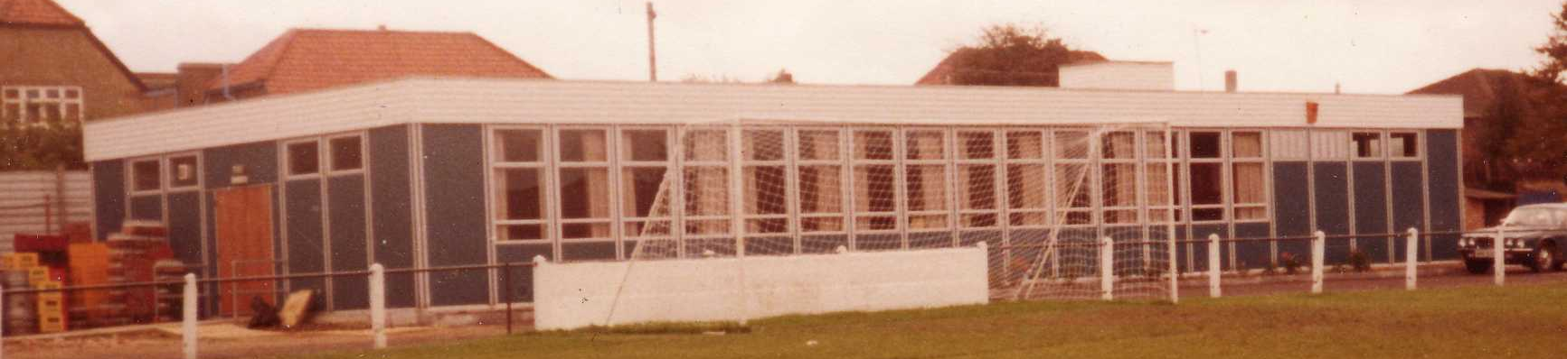

CCL Premier Division Club Directory
ABBEY RANGERS Telephone: 01932-422962 - Colours: Black & White Stripes/Black/Black
Ground: Addlestone Moor, Addlestone. KT15 2QH

A.F.C. HAYES Telephone: 0208-845-0110 - Colours: Blue and White Stripes/Blue/Blue
Ground: Farm Park, Kingshill Avenue, Hayes. UB4 8DD

BALHAM Telephone: 0208-942 8062 - Colours: White & Black/Black/Black

Ground: Colliers Wood United FC - Wibbandune, Robin Hood Way, Wimbledon. SW20 0AA -

BANSTEAD ATHLETIC Telephone: 01737-350982 - Colours: Amber &Black/Black/Black
Ground: Banstead Athletic, Merland Rise, Tadworth. KT20 5JG

BEDFONT SPORTS Telephone: 0208-831-9067 - Colours: Red & Black Hoops/Black/Red & Black
Ground: Bedfont Sports Club, Hatton Road, Bedfont. TW14 8JA

CAMBERLEY TOWN Telephone: 01276-65392 Colours: Red & White Stripes/Blue/Red
Ground: Krooner Park, Wilton Road, Camberley. GU15 2QW

CB HOUNSLOW UNITED Telephone: 0208-577 -9712 Colours: Green/Black/Green
Ground: CB Hounslow Sports Ground, Green Lane, Hounslow TW4 6DH

CHERTSEY TOWN Telephone: 01932-561774 - Colours: Royal Blue & White Stripes/ Blue/ Blue
Ground: Alwyns Lane, Chertsey. KT16 9DW

COLLIERS WOOD UNITED Telephone: 0208-942 8062 - Colours: Royal Blue/Black/Black
Ground: Wibbandune, Robin Hood Way, Wimbledon. SW20 0AA

EPSOM & EWELL Telephone: 01737-553250 - Colours: Royal Blue & White Hoops/Royal Blue/Royal Blue - Ground: Chipstead FC, High Road, Chipstead. CR5 3SF

FARNHAM TOWN Telephone: 01252-715305 - Colours: - Claret & Sky Blue /White/ Claret & Blue
Ground: Memorial Ground, Babbs Mead, West Street, Farnham. GU9 7DY

GODALMING TOWN Telephone: 01483-417520 - Colours: Yellow/Green/Yellow
Ground: Wey Court, Meadrow, Godalming. GU7 3JE

GUILDFORD CITY Telephone: 01483-443322 - Colours: Red & White Stripes/Black/Black
Ground: The Spectrum, Parkway, Guildford, Surrey. GU1 1UP

HANWORTH VILLA Telephone: 0208-831-9391 - Colours: Red & White Stripes/Black/Black
Ground: Rectory Meadows, Park Road, off Hounslow Road, Hanworth. TW13 6PN

HORLEY TOWN Telephone: 01293-822000 - Colours: Claret & Sky Blue/Claret/Claret
Ground: The New Defence, Anderson Way, Court Lodge Road, Horley. RH6 8SP

KNAPHILL Telephone: 01483-475150 - Colours: Red/Black/Red & Black
Ground: Brookwood Country Park, Redding Way, Lower Guildford Road, Knaphill. GU21 2AY

NORTH GREENFORD UNITED Telephone: 0208 422 8923 - Colours: Royal Blue & White/Royal Blue/Royal Blue - Ground: Berkeley Fields, Berkeley Avenue, Greenford, Middx UB6 0NX

REDHILL Telephone: 01737-762129 - Colours: Red and White Stripes/Red/Red
Ground: Kiln Brow, Three Arch Road, Redhill. RH1 5AG

SPELTHORNE SPORTS Telephone: 01932-961055 - Colours: Navy & Sky Blue/ Blue/ Blue
Ground: Spelthorne Sports Club, 296 Staines Road, Ashford Common, Ashford. TW15 1RY

SUTTON COMMON ROVERS Telephone: 0208-644-4440 - Colours: Yellow/ Yellow / Yellow
Ground: Sutton United FC, Gander Green Lane, Sutton. SM1 2EY

WALTON & HERSHAM Telephone: 01932-245263 - Colours: Red & White Trim/Red/Red
Ground: Stompond Lane, Walton on Thames. KT12 1HF

WESTFIELD Telephone: 01483-771106 - Colours: Yellow/Black/Black
Ground: Woking Park, Kingfield Road, Woking. GU22 9BA

Salts Super Six Predictor
The Salts Super Six Predictor is live again today and the tickets are on sale at today’s game to the left of the gate. The matches are to be played at some point today.

The jackpot is already up to £362 which if won would represent the third largest individual prize so far and who knows how much higher it could rise!

The competition is easy to play! To win, you simply need to predict the results of six matches correctly from the three options, fill in the form and make sure it is back with our seller before the deadline on the ticket. The latest fixtures are shown below.

If you are a club regular, you just need to place your name on the sheet, although if you aren’t, then we’ll need a contact number from you too. We will announce any winners on the website within three working days, so don’t worry, we won’t miss you!

Please note that if there is more than one winner, the prize pot would be shared between the winners. All you need to do now is have a go, as many times as you like!

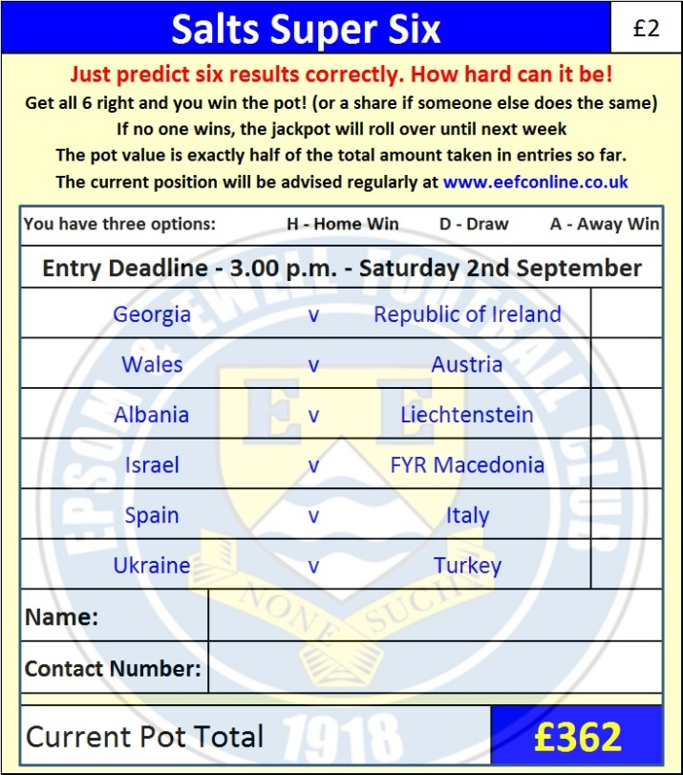

Good luck!

Combined Counties League – Premier Division
Saturday, 2nd September 2017 - Kick-off 3.00 p.m.
Epsom and Ewell  (Royal Blue & White hoops) | V |  | Redhill  (All Yellow)
Squad | NUMBERS |  | Squad
Colin Harris |  |  | Rhys Hughes
Reisse Griffin |  |  | Liam Sallis
Ben Dyson |  |  | Jason Stripp
Ashley Thompson |  |  | Ben Mizen
Scott Murphy |  |  | James Bessant
Louis O’Brien |  |  | Jacob Mendy-Mendy
Ben Hayward |  |  | Jonathan Trotter
© Sam Robinson |  |  | Asjley Snadden
Kyle Hough |  |  | Qudus Bolagi
Joe Loftus-Cheek |  |  | Scott Buchanan
Rob Hendry |  |  | Nathan Oliver
Dale Marvell |  |  | Keith Clark
Daniel Rose |  |  | Eno Idiong
Antony ‘Freddy’ Myers |  |  | Chris Ransome
Jason Nwachukwu |  |  | Martin Smith
Jordan Brooks |  |  | Conner Westney
Sean White |  |  | Gary Abisogun
Liam Roberts |  |  | Steve Burford
Tayo Ajayi |  |  | Kerry Kedze
Ali Dewar |  |  | Mohamed Diakite
Tom Harland-Goddard |  |  | Jesse Sentamu
Alistair Turpie |  |  | Tony Halsey
Cristian Castell
Andy Smith
Glyn Mandeville | MANAGER |  | Gavin Gordon
Matt Smith | ASSISTANT |  | Darrell Teasdale
Alex McKay / Jimmy Hendry | COACHES / PHYSIO |  | Barry Wilde
REFEREE: J.Oxenham
ASSISTANTS: K.Corrick, M.Stevens
Today’s Match and Match Ball are kindly sponsored by:
Building Shop Ltd

OUR NEXT VISITORS TO HIGH ROAD
Spelthorne Sports
Cherry Red Combined Counties League – Premier Division
Saturday 9th September 2017

